Insert at the head of a Linked List
Problem Statement: Given a linked list and an integer value val, insert a new node with that value at the beginning (before the head) of the list and return the updated linked list.
Examples

Example 1:

Input Format: 0->1->2, val = 5

Result: 5->0->1->2

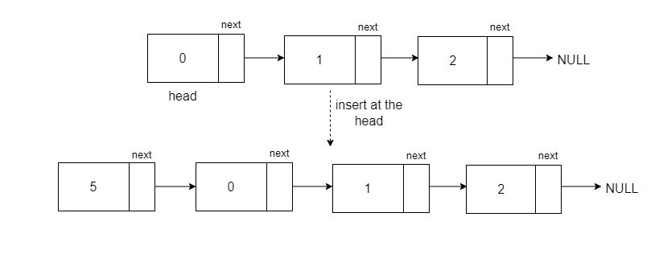
Explanation: We need to insert the value 5 before the head of the given Linked List.

Approach:
To insert a new node with a value before the head of the list, create a new node with the given value val pointing to the head. This node will be the new head of the linked list.
Algorithm:
- Create a new node with data as the given value and pointing to the head. This node will be our new head of the linked list.
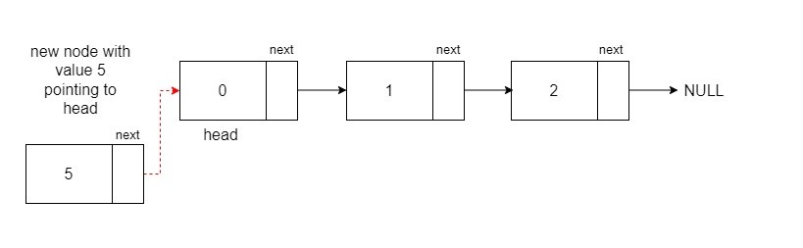
- Now, return the new node as the head of the updated Linked List.
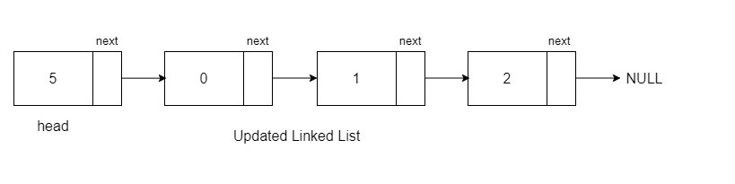

Code:-
C++
class Node {
public:
int data;
Node* next;

// Constructor with both data and next node
Node(int data1, Node* next1) {
data = data1;
next = next1;
}

// Constructor with only data (assuming next is initially null)
Node(int data1) {
data = data1;
next = nullptr;
}
};

// Function to print the linked list
void printLL(Node* head) {
while (head != NULL) {
cout << head->data << " ";
head = head->next;
}
}

// Function to insert a new node at the head of the linked list
Node* insertHead(Node* head, int val) {
Node* temp = new Node(val, head);
return temp;
}

int main() {
// Sample array and value for insertion
vector<int> arr = {12, 8, 5, 7};
int val = 100;

// Creating a linked list with initial elements from the array
Node* head = new Node(arr[0]);
head->next = new Node(arr[1]);
head->next->next = new Node(arr[2]);
head->next->next->next = new Node(arr[3]);

// Inserting a new node at the head of the linked list
head = insertHead(head, val);

// Printing the linked list
printLL(head);

return 0;
}

Java
// Node class to represent a linked list node
class Node {
public int data;
public Node next;

// Constructor with both data and next node
public Node(int data1, Node next1) {
data = data1;
next = next1;
}

// Constructor with only data (assuming next is initially null)
public Node(int data1) {
data = data1;
next = null;
}
}

public class Main {
// Function to print the linked list
public static void printLL(Node head) {
while (head != null) {
System.out.print(head.data + " ");
head = head.next;
}
}

// Function to insert a new node at the head of the linked list
public static Node insertHead(Node head, int val) {
Node temp = new Node(val, head);
return temp;
}

public static void main(String[] args) {
// Sample array and value for insertion
List<Integer> arr = Arrays.asList(12, 8, 5, 7);
int val = 100;

// Creating a linked list with initial elements from the array
Node head = new Node(arr.get(0));
head.next = new Node(arr.get(1));
head.next.next = new Node(arr.get(2));
head.next.next.next = new Node(arr.get(3));

// Inserting a new node at the head of the linked list
head = insertHead(head, val);

// Printing the linked list
printLL(head);
}
}

Output:
100 12 8 5 7
Time Complexity: O(1) for inserting the new head of the linked list and O(N) for printing the linked list.
Space Complexity: O(1), as we have not used any extra space.

